**CNH Buyback Inquiry:** The CNH Buyback Inquiry lets you look up current information about your verified buybacks, both submitted and not submitted. In the case of your verified, but not submitted buybacks, you can also re-verify, cancel, and submit them from this screen.

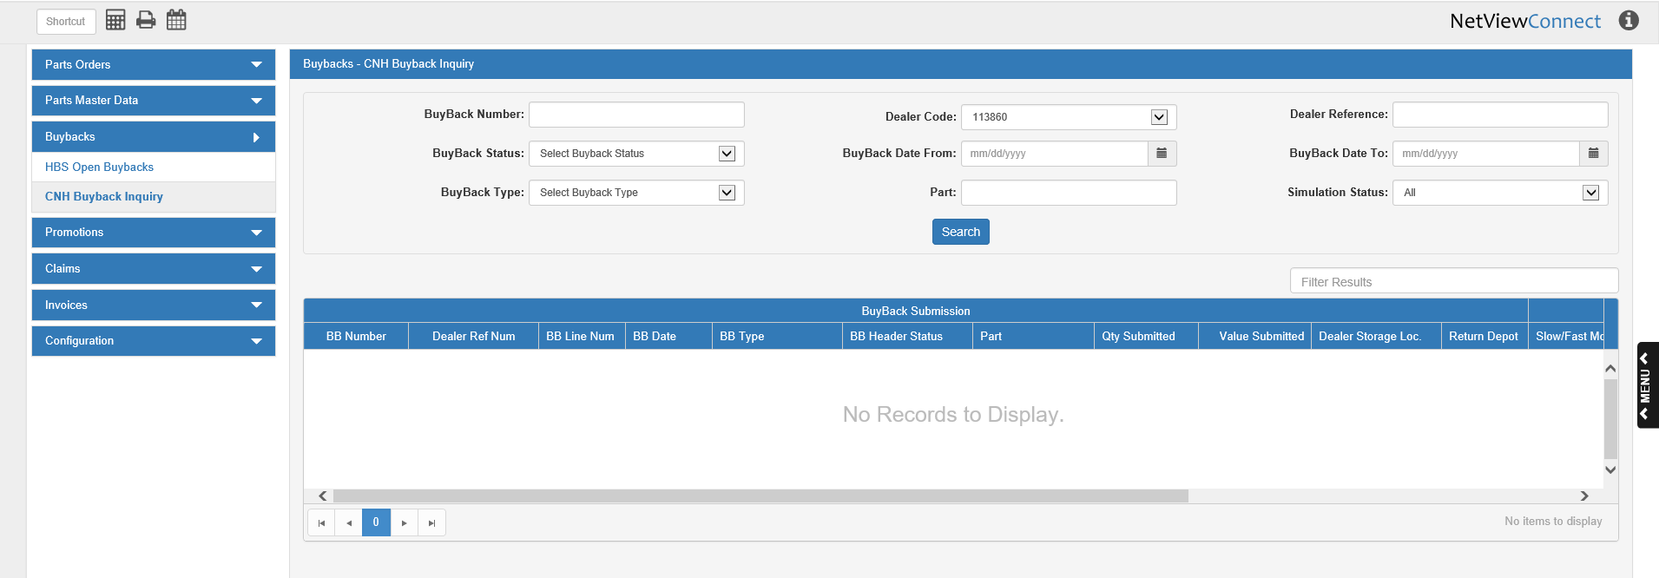

**Search Filter Fields:**

Buyback Number: To search by the CNH-assigned buyback number, enter the number here.

Dealer Code: Select a dealer code to search by from this drop-down menu. This mainly applies to dealers that have more than one CNH code and so could have assigned different codes to different buybacks.

Dealer Reference: To search by the dealer-assigned buyback number, enter the number here.

Buyback Status: To search by the buyback status, select a status from this drop-down menu.

Buyback Date From/To: To search by a range of buyback dates, enter the starting and ending dates in these fields or select them from a calendar. To search for a specific buyback date, enter the date in both fields.

Buyback Type: To search by the buyback type, select it from the drop-down menu.

Part: To search by a part number on the buyback, enter the number here.

Simulation Status: To search by the buyback’s simulation status, select a status from the drop-down menu.

**Search:** Click this button to start the search. The grid will populate with the search results. You can sort the buyback list using the column headers, or filter it by entering specific information in the **Filter Results** field.

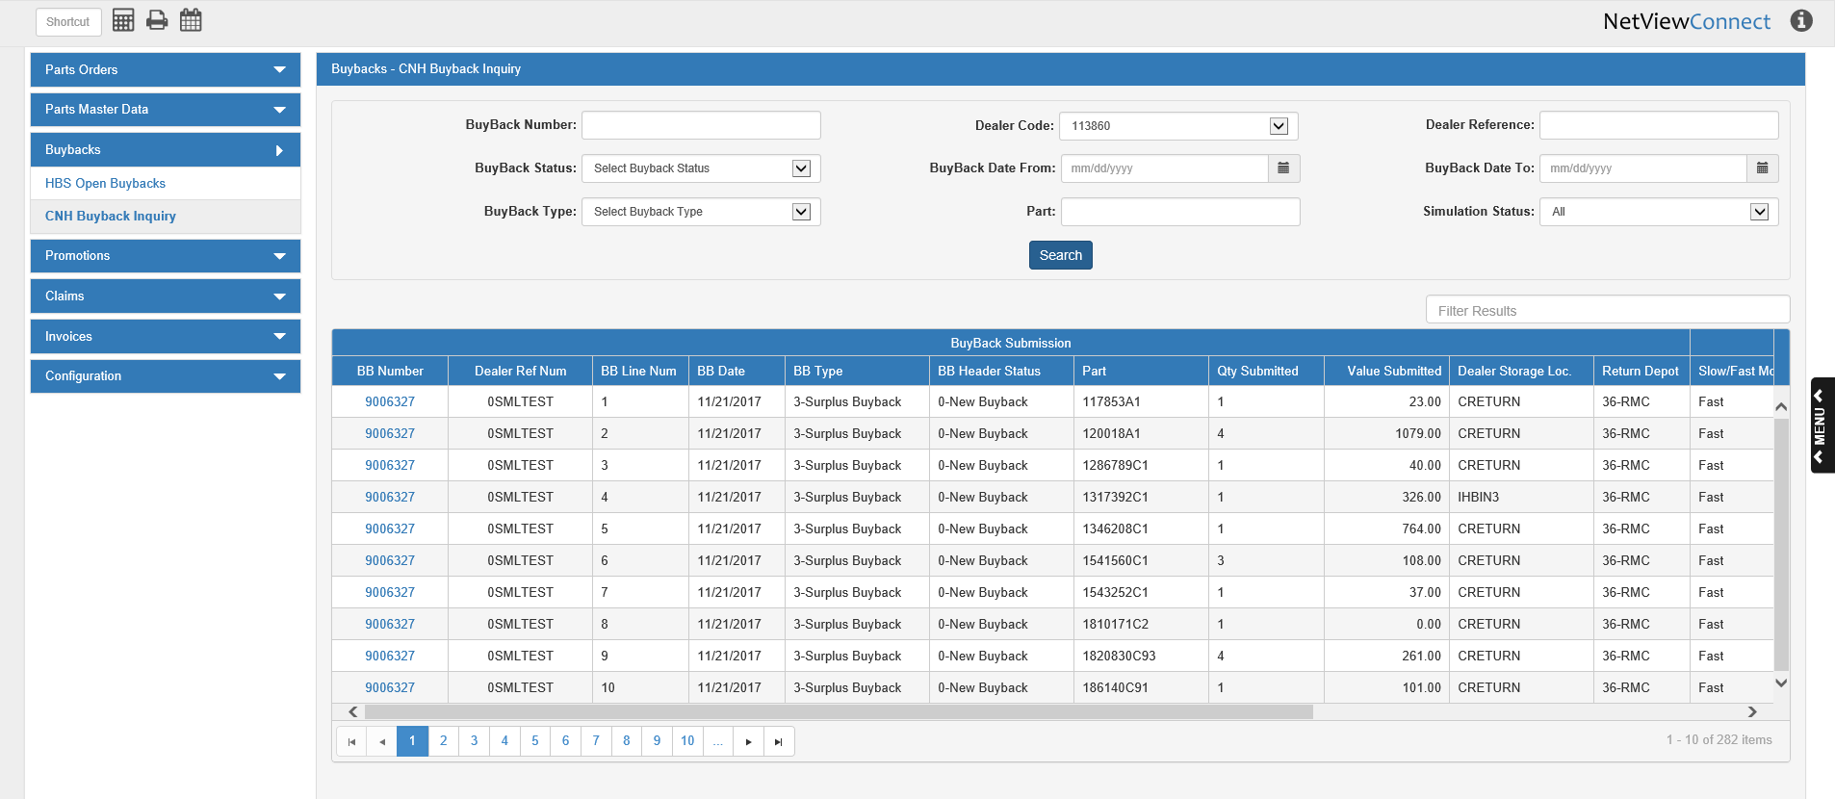

**Column Headers:** The grid is divided into 3 sections by the type of information contained in the columns:

* Buyback Submission
* Buyback Evaluation
* Buyback Finance Docs

Buyback Submission Columns:

**BB Number:** This column shows the CNH-assigned buyback number. Click on the number to view the buyback details (see image below).

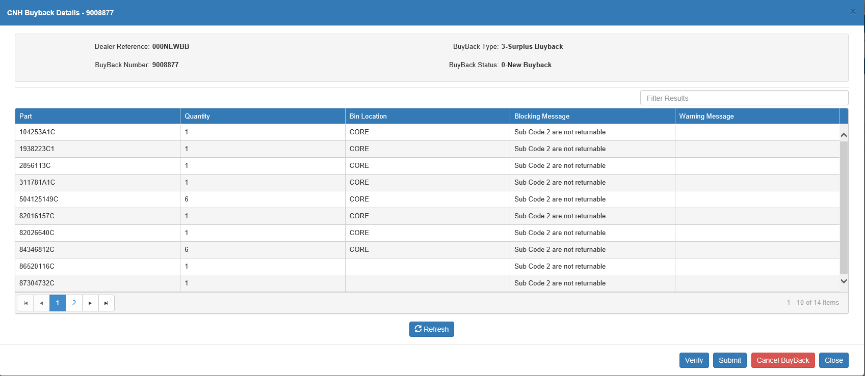

You can sort the buyback lines using the column headers, or filter them by entering specific information in the **Filter Results** field.

* **Dealer Reference:** This field shows the dealer-assigned buyback number.
* **Buyback Number:** This field shows the CNH-assigned buyback number.
* **Buyback Type:** This field shows the buyback type.
* **Buyback Status:** This field shows the buyback’s current status.
* **Grid Columns:**
  + **Part:** This column shows the part number for the buyback line.
  + **Quantity:** This column shows the part quantity for the buyback line.
  + **Bin Location:** This column shows the bin location for the part on the buyback line.
  + **Blocking Message:** If there is an error blocking a buyback line from being submitted, a blocking message will appear here.
  + **Warning Message:** If there is a warning on a buyback line, a warning message will appear here.
* **Refresh:** Click this button to update the buyback details. Any changes made to the buyback since it was opened in this screen will appear.
* **Verify:** Click this button to re-send the buyback for verification. We recommend this particularly after you have corrected any blockers on the buyback to make sure that the blocking messages have been removed. **NOTE:** If the buyback has already been submitted to CNH, this button will be inactive.
* **Submit:** Click this button to submit the buyback to CNH for processing. **NOTE:** If the buyback has already been submitted to CNH, this button will be inactive.
* **Cancel Buyback:** Click this button to cancel the buyback. **NOTE:** If the buyback has already been submitted to CNH, this button will be inactive.
* **Close:** Click this button to close the screen.



**Dealer Ref Num:** This column shows the dealer-assigned buyback number.

**BB Line Num:** This column shows the line number of the buyback for the grid entry, as the grid splits the results into individual buyback lines (one entry per line).

**BB Date:** This column shows the buyback date.

**BB Type:** This column shows the buyback type.

**BB Header Status:** This column shows the buyback status for the entire order (rather than for a specific line).

**Part:** This column shows the part number for the buyback line.

**Qty Submitted:** This column shows the quantity of the part submitted on the buyback line.

**Value Submitted:** This column shows the dollar value of the buyback line.

**Dealer Storage Loc.:** This column shows the dealer storage location where the parts for the buyback line are currently located.

**Return Depot:** This column shows the location of the CNH return depot that will receive the accepted parts from the buyback line.

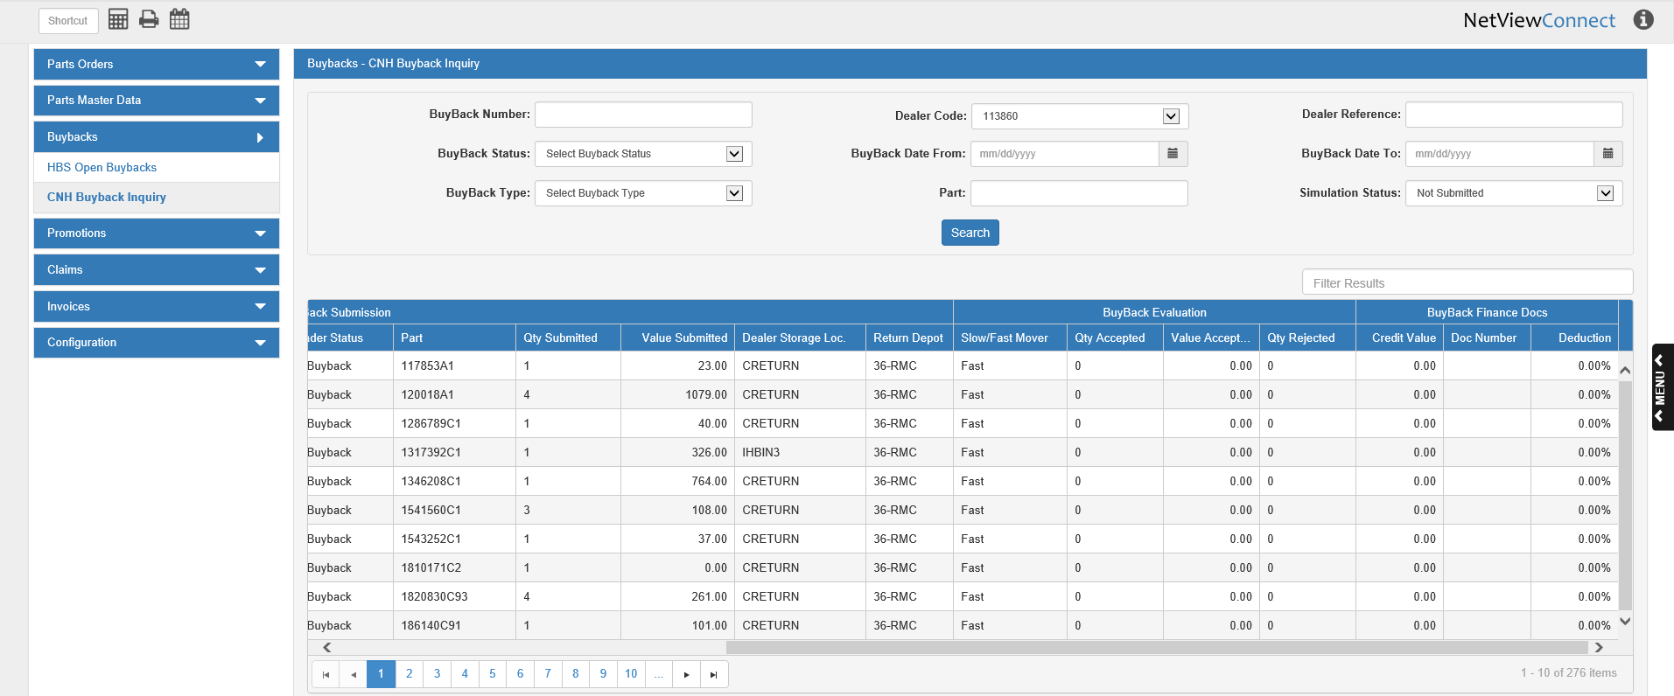

Buyback Evaluation Columns:

**Slow/Fast Mover:** This column indicates whether the part on the buyback line is a slow or fast mover.

**Qty Accepted:** This column shows the quantity of the part on the buyback line accepted by CNH.

**Value Accepted:** This column shows the dollar value of the accepted parts.

**Qty Rejected:** This column shows the quantity of the part on the buyback line rejected by CNH.

Buyback Finance Docs Columns:

**Credit Value:** This column shows the credit value awarded to the buyback line.

**Doc Number:** This column shows the document number of the line’s credit memo, if applicable.

**Deduction:** This column shows the deduction percentage awarded to the buyback line.